2015 Lenten Luncheon Series
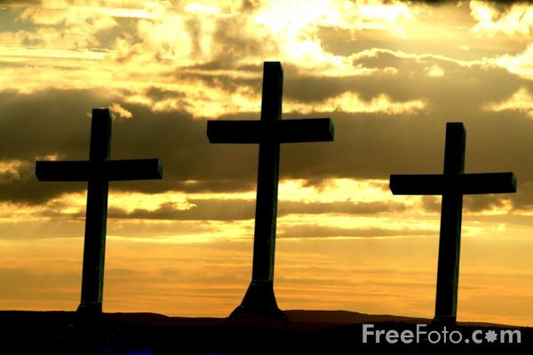
Speaking Peace in a Violent World
Sponsored by the Grinnell Ministerial Association
12:10 p.m. with a light lunch at 12:30

A freewill offering ($5 suggested) will be taken for the meal and the ongoing ministry of the Ministerial Association. On Good Friday, April 3, there will be an expanded time of reflection and discussion. There will be no meal following the Good Friday service.

February 25 United Church of Christ Congregational Dr. Dondrea Walker
Systemic Violence: Exodus 1:11-14

March 4 St. Mary’s Catholic Church Rev. Branden Bradley
Family Violence: Genesis 4:8-12

March 11 St. John’s Lutheran Church Rev. Cameron Barr
Self-inflicted Violence: Judges 16:26-30

March 18 First Baptist Church Rev. Wendy Abrahamson
Loving Your Enemy: Matthew 5:43-48

March 25 United Methodist Church Rev. Christine Pauley
Speaking the Truth to Power: Acts 16:37-39

April 3 (Good Friday) Herrick Chapel Rev. Kirsten Klepfer
Panel Discussion: Redemptive Suffering: Luke 23:44-49

